Inventory Database

1. Display the state, number of clients, total balance due and average balance due for states having at least two clients, considering only clients whose names contain the letter 'a' and whose balance due is greater than 1000.
SELECT State, COUNT(*) AS Num_Clients, SUM(BalDue) AS Total_BalDue, AVG(BalDue) AS Avg_BalDue FROM Cust_Master WHERE Name LIKE '%a%' AND BalDue > 1000 GROUP BY State HAVING COUNT(*) >= 2;
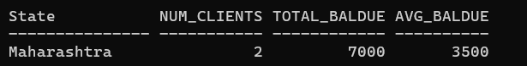
2. Display the product number, description, selling price, cost price and calculated profit percentage for products whose description contains the word 'Shirt' and whose selling price is greater than 400, rounding the calculated profit percentage to two decimal places.
SELECT ProductNo, Description, SellPrice, CostPrice, ROUND(((SellPrice - CostPrice)/CostPrice)*100, 2) AS Profit_Percent FROM Prod_Master
WHERE Description LIKE '%Shirt%' AND SellPrice > 400;
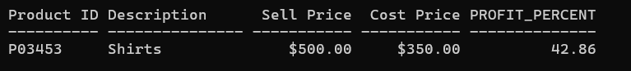
3. Display the month of order placement, number of orders, earliest order date, latest delivery date and average delivery duration for months having more than one order, considering only orders placed during 2014.
SELECT TO_CHAR(OrderDate,'MON') AS Order_Month, COUNT(*) AS Num_Orders, MIN(OrderDate) AS Earliest_Order, MAX(DelyDate) AS Latest_Dely, AVG(DelyDate - OrderDate) AS Avg_Dely_Duration FROM Sales_Order WHERE TO_CHAR(OrderDate,'YYYY') = '2014' GROUP BY TO_CHAR(OrderDate,'MON') HAVING COUNT(*) > 1 ORDER BY MIN(OrderDate);
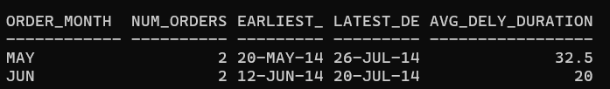
4. Display the city, number of clients, maximum balance due and minimum balance due for cities having at least two clients and a maximum balance due greater than 2000.
SELECT City, COUNT(*) AS Num_Clients, MAX(BalDue) AS Max_BalDue, MIN(BalDue) AS Min_BalDue
FROM Cust_Master
GROUP BY City
HAVING COUNT(*) >= 2 AND MAX(BalDue) > 2000;
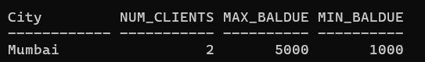
5. Display the unit measure, number of products, total quantity on hand and average selling price for unit measures having more than one product, considering only products whose selling price is greater than 300 and whose quantity on hand is not equal to the reorder level.
SELECT UnitMeasure, COUNT(*) AS Num_Products, SUM(QtyOnHand) AS Total_Qty, ROUND(AVG(SellPrice), 2) AS Avg_SellPrice FROM Prod_Master WHERE SellPrice > 300 AND QtyOnHand <> ReorderLvl GROUP BY UnitMeasure HAVING COUNT(*) > 1;
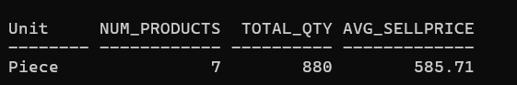
6. Display the payment mode, number of orders and average delivery duration for payment modes having more than one order, considering only orders delivered within 60 days of the order date.
SELECT Payment_Mode, COUNT(*) AS Num_Orders, AVG(DelyDate - OrderDate) AS Avg_Dely_Duration FROM Sales_Order WHERE (DelyDate
- OrderDate) <= 60 GROUP BY Payment_Mode HAVING COUNT(*) > 1;
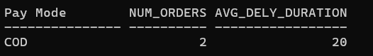
7. Display the product number, total quantity ordered, total quantity dispatched and difference between total quantity ordered and total quantity dispatched for products whose description contains the letter 's', showing only products for which the total quantity ordered exceeds the total quantity dispatched.
SELECT ProductNo, SUM(QtyOrdered) AS Total_Qty_Ordered, SUM(QtyDisp) AS Total_Qty_Disp,SUM(QtyOrdered) - SUM(QtyDisp) AS Difference FROM Order_DetailsGROUP BY ProductNo HAVING SUM(QtyOrdered) > SUM(QtyDisp);
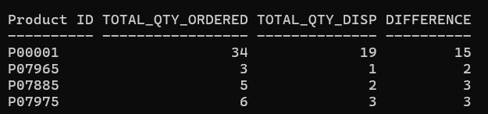
8. Display the order number, number of products, total quantity ordered and total quantity dispatched for orders containing more than one product and having a total quantity ordered greater than 5.
SELECT OrderNo, COUNT(*) AS Num_Products, SUM(QtyOrdered) AS Total_Qty_Ordered, SUM(QtyDisp) AS Total_Qty_Disp FROM Order_Details GROUP BY OrderNo HAVING COUNT(*) > 1 AND SUM(QtyOrdered) > 5;
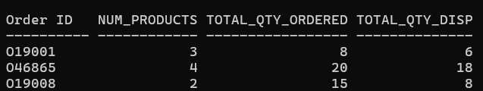
9. Display the state, total balance due, average balance due and number of clients for states whose client names start with 'A' or 'M', showing only states having total balance due greater than 1000.
SELECT State, SUM(BalDue) AS Total_BalDue, AVG(BalDue) AS Avg_BalDue, COUNT(*) AS Num_Clients FROM Cust_Master WHERE Name LIKE 'A%' OR Name LIKE 'M%' GROUP BY State HAVING SUM(BalDue) > 1000;
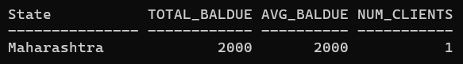
10. Display the year of order placement, number of orders, total number of products ordered and average quantity ordered for each year, showing only years having more than one order.
SELECT TO_CHAR(OrderDate,'YYYY') AS Order_Year, COUNT(*) AS Num_Orders FROM Sales_Order GROUP BY TO_CHAR(OrderDate,'YYYY') HAVING COUNT(*) > 1;
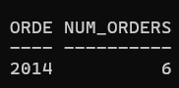
SELECT SUM(QtyOrdered) AS Total_Qty_Ordered, AVG(QtyOrdered) AS Avg_Qty_Ordered FROM Order_Details;
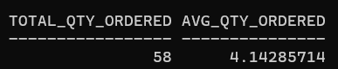
11. Display the product number, description, selling price and new selling price after a 15% increase for products whose description starts with 'T' or 'J' and whose current selling price is between 300 and 800.
SELECT ProductNo, Description, SellPrice, SellPrice*1.15 AS New_SellPrice FROM Prod_Master WHERE (Description LIKE 'T%' OR Description LIKE 'J%') AND SellPrice BETWEEN 300 AND 800;
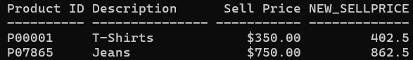
12. Display the city and number of clients for cities whose names contain the letter 'a', showing only cities having at least two such clients and ordering the result by the number of clients in descending order.
SELECT City, COUNT(*) AS Num_Clients FROM Cust_Master WHERE City LIKE '%a%' GROUP BY City HAVING COUNT(*) >= 2 ORDER BY COUNT(*) DESC;
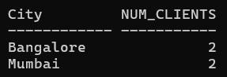
13. Display the order status, number of orders, average delivery duration and maximum delivery duration for statuses having at least two orders, considering only orders with delivery dates in July 2014.
SELECT OrderStatus, COUNT(*) AS Num_Orders, AVG(DelyDate - OrderDate) AS Avg_Dely_Duration, MAX(DelyDate - OrderDate) AS Max_Dely_Duration FROM Sales_Order WHERE TO_CHAR(DelyDate,'MON-YYYY') = 'JUL-2014' GROUP BY OrderStatus
HAVING COUNT(*) >= 2;
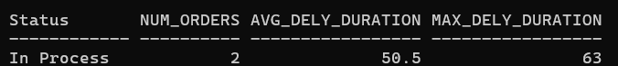
14. Display the unit measure, total quantity on hand, average cost price, minimum selling price and maximum selling price for unit measures whose average selling price is greater than 400 and total quantity on hand exceeds 150.
SELECT UnitMeasure, SUM(QtyOnHand) AS Total_Qty_OnHand, AVG(CostPrice) AS Avg_CostPrice,
MIN(SellPrice) AS Min_SellPrice, MAX(SellPrice) AS Max_SellPrice
FROM Prod_Master
GROUP BY UnitMeasure
HAVING AVG(SellPrice) > 400 AND SUM(QtyOnHand) > 150;
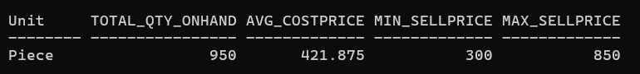
15. Display the order number, order date, delivery date and number of days taken for delivery for orders where the delivery duration is greater than 10 days and the order status is not 'Cancelled'.
SELECT OrderNo, OrderDate, DelyDate, (DelyDate - OrderDate) AS Days_Taken
FROM Sales_Order
WHERE (DelyDate - OrderDate) > 10 AND OrderStatus <> 'Cancelled';
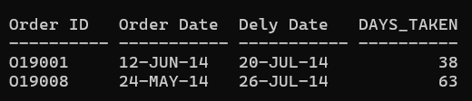
16. Display the client number, name, city and balance due for clients whose names contain exactly six characters and whose balance due is between 1000 and 15000.
SELECT ClientNo, Name, City, BalDue
FROM Cust_Master
WHERE LENGTH(Name) = 6 AND BalDue BETWEEN 1000 AND 15000;
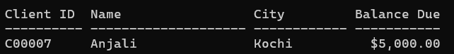
17. Display the product number, description, quantity on hand and reorder level for products whose quantity on hand is below the reorder level, and display the shortage using an appropriate arithmetic expression.
SELECT ProductNo, Description, QtyOnHand, ReorderLvl, (ReorderLvl - QtyOnHand) AS Shortage
FROM Prod_Master
WHERE QtyOnHand < ReorderLvl;
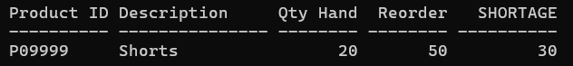
18. Display the state, number of clients, average balance due and total balance due for states having at least two clients and an average balance due greater than 1000, considering only clients whose names end with the letter 'a'.
SELECT State, COUNT(*) AS Num_Clients, AVG(BalDue) AS Avg_BalDue, SUM(BalDue) AS Total_BalDue
FROM Cust_Master
WHERE Name LIKE '%a'
GROUP BY State
HAVING COUNT(*) >= 2 AND AVG(BalDue) > 1000;
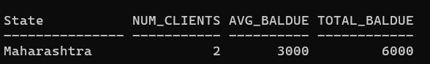
19. Display the payment mode, number of orders, earliest order date and latest order date for payment modes used more than once, considering only orders whose delivery type is 'F'.
SELECT Payment_Mode, COUNT(*) AS Num_Orders, MIN(OrderDate) AS Earliest_Order, MAX(OrderDate) AS Latest_Order
FROM Sales_Order
WHERE DelyType = 'F'
GROUP BY Payment_Mode
HAVING COUNT(*) > 1;
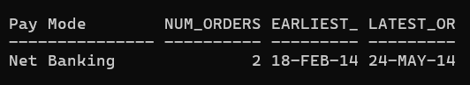
20. Display the product number, description, number of order-detail records, total quantity ordered and maximum quantity ordered for products appearing in more than one order-detail record.
SELECT ProductNo, COUNT(*) AS Num_Records, SUM(QtyOrdered) AS Total_Qty_Ordered, MAX(QtyOrdered) AS Max_Qty_Ordered
FROM Order_Details
GROUP BY ProductNo
HAVING COUNT(*) > 1;
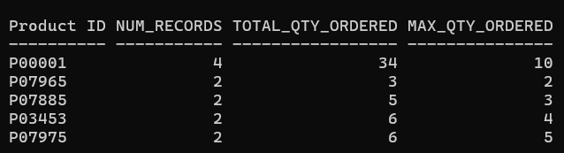
21. Display the order number, total quantity ordered, total quantity dispatched and percentage of quantity dispatched for orders having more than one product, showing only orders where the percentage dispatched is less than 80%.
SELECT OrderNo, SUM(QtyOrdered) AS Total_Qty_Ordered, SUM(QtyDisp) AS Total_Qty_Disp,
ROUND(SUM(QtyDisp)/SUM(QtyOrdered)*100, 2) AS Pct_Dispatched
FROM Order_Details
GROUP BY OrderNo
HAVING COUNT(*) > 1 AND (SUM(QtyDisp)/SUM(QtyOrdered)*100) < 80
ORDER BY OrderNo;
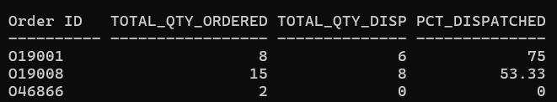
22. Display the city, number of clients, total balance due and average balance due for clients whose names contain 'an', considering only cities having at least two such clients.
SELECT City, COUNT(*) AS Num_Clients, SUM(BalDue) AS Total_BalDue, AVG(BalDue) AS Avg_BalDue
FROM Cust_Master
WHERE Name LIKE '%an%'
GROUP BY City
HAVING COUNT(*) >= 2;
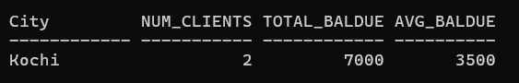
23. Display the month name of the order date, number of orders and average delivery duration for each month, showing only months whose average delivery duration is greater than 10 days.
SELECT TO_CHAR(OrderDate,'MON') AS Order_Month, COUNT(*) AS Num_Orders,
AVG(DelyDate - OrderDate) AS Avg_Dely_Duration
FROM Sales_Order
GROUP BY TO_CHAR(OrderDate,'MON')
HAVING AVG(DelyDate - OrderDate) > 10;
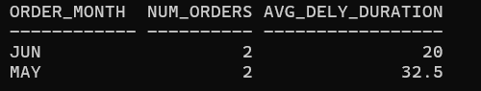
24. Display the unit measure, number of products, average profit percentage and maximum profit percentage for unit measures having at least two products and an average profit percentage greater than 3%.
SELECT UnitMeasure, COUNT(*) AS Num_Products, ROUND(AVG(ProfitPercent),2) AS Avg_Profit_Percent,
MAX(ProfitPercent) AS Max_Profit_Percent
FROM Prod_Master
GROUP BY UnitMeasure
HAVING COUNT(*) >= 2 AND AVG(ProfitPercent) > 3;
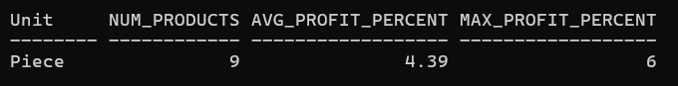
25. Display the product number, description, selling price, cost price and rounded profit amount for products whose profit percentage is greater than 4% and whose selling price exceeds 500.
SELECT ProductNo, Description, SellPrice, CostPrice, ROUND(SellPrice - CostPrice, 2) AS Profit_Amount
FROM Prod_Master
WHERE ProfitPercent > 4 AND SellPrice > 500;
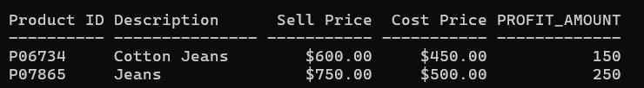
26. Display the order status, number of orders, total quantity ordered and average quantity ordered for order-detail records grouped by order number, showing only groups having total quantity ordered greater than 10.
SELECT OrderNo, COUNT(*) AS Num_Records, SUM(QtyOrdered) AS Total_Qty_Ordered, AVG(QtyOrdered) AS Avg_Qty_Ordered
FROM Order_Details
GROUP BY OrderNo
HAVING SUM(QtyOrdered) > 10;
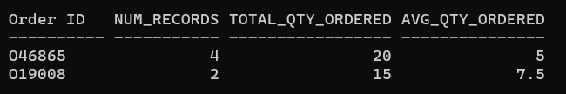
27. Display the year of order placement, number of orders, total quantity ordered and average quantity ordered for each year, showing only years having at least two orders.
SELECT TO_CHAR(OrderDate,'YYYY') AS Order_Year, COUNT(*) AS Num_Orders
FROM Sales_Order
GROUP BY TO_CHAR(OrderDate,'YYYY')
HAVING COUNT(*) >= 2;
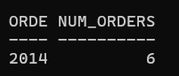
SELECT SUM(QtyOrdered) AS Total_Qty, AVG(QtyOrdered) AS Avg_Qty FROM Order_Details;
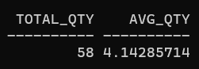
28. Display the city, number of clients and maximum balance due for cities whose names begin with 'M' or 'B', showing only cities whose maximum balance due exceeds 1000.
SELECT City, COUNT(*) AS Num_Clients, MAX(BalDue) AS Max_BalDue
FROM Cust_Master
WHERE City LIKE 'M%' OR City LIKE 'B%'
GROUP BY City
HAVING MAX(BalDue) > 1000;
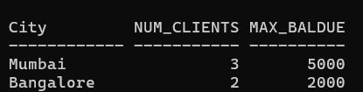
29. Display the product number, description, selling price and cost price for products where the selling price is at least twice the cost price or the profit percentage is greater than 5%, and whose description contains the letter 's'.
SELECT ProductNo, Description, SellPrice, CostPrice
FROM Prod_Master
WHERE (SellPrice >= 2*CostPrice OR ProfitPercent > 5) AND Description LIKE '%s%';
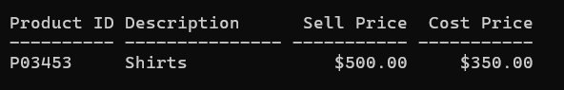
30. Display the order number, order date, day name on which the order was placed and delivery duration for orders placed after 01-APR-2014 and delivered within 30 days.
SELECT OrderNo, OrderDate, TO_CHAR(OrderDate,'DAY') AS Day_Name, (DelyDate - OrderDate) AS Dely_Duration
FROM Sales_Order
WHERE OrderDate > TO_DATE('01-APR-2014','DD-MON-YYYY') AND (DelyDate - OrderDate) <= 30;
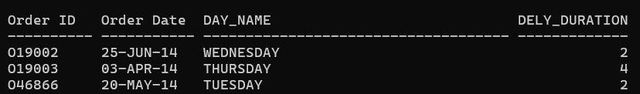
31. Display the state, number of clients, minimum balance due, maximum balance due and total balance due for states having more than one client, excluding clients with zero balance due.
SELECT State, COUNT(*) AS Num_Clients, MIN(BalDue) AS Min_BalDue, MAX(BalDue) AS Max_BalDue, SUM(BalDue) AS Total_BalDue
FROM Cust_Master
WHERE BalDue <> 0
GROUP BY State
HAVING COUNT(*) > 1;
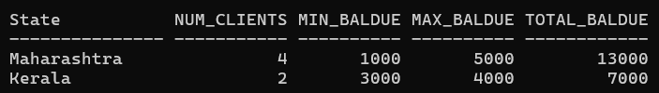
32. Display the product number, description, quantity on hand, reorder level and percentage by which quantity on hand exceeds reorder level for products whose quantity on hand is greater than the reorder level.
SELECT ProductNo, Description, QtyOnHand, ReorderLvl,
ROUND((QtyOnHand - ReorderLvl)/ReorderLvl*100, 2) AS Pct_Exceed
FROM Prod_Master
WHERE QtyOnHand > ReorderLvl;
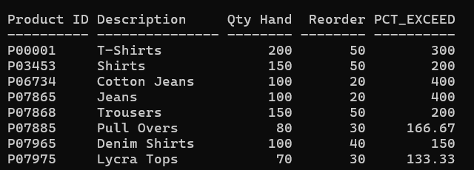
33. Display the payment mode and delivery type combination, number of orders and average delivery duration for combinations having more than one order and an average delivery duration greater than 5 days.
SELECT Payment_Mode, DelyType, COUNT(*) AS Num_Orders, AVG(DelyDate - OrderDate) AS Avg_Dely_Duration
FROM Sales_Order
GROUP BY Payment_Mode, DelyType
HAVING COUNT(*) > 1 AND AVG(DelyDate - OrderDate) > 5;
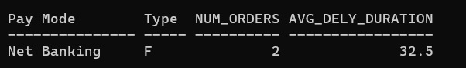
34. Display the order number, number of products, total quantity ordered and total quantity dispatched for orders having at least two order-detail records and total quantity ordered greater than 10.
SELECT OrderNo, COUNT(*) AS Num_Products, SUM(QtyOrdered) AS Total_Qty_Ordered, SUM(QtyDisp) AS Total_Qty_Disp
FROM Order_Details
GROUP BY OrderNo
HAVING COUNT(*) >= 2 AND SUM(QtyOrdered) > 10;
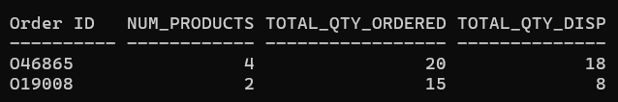
35. Display the unit measure, number of products, total quantity on hand and average reorder level for unit measures having more than two products and total quantity on hand greater than 250.
SELECT UnitMeasure, COUNT(*) AS Num_Products, SUM(QtyOnHand) AS Total_Qty_OnHand, AVG(ReorderLvl) AS Avg_ReorderLvl
FROM Prod_Master
GROUP BY UnitMeasure
HAVING COUNT(*) > 2 AND SUM(QtyOnHand) > 250;
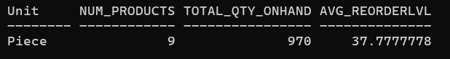
36. Display the state and city combination, number of clients and total balance due for combinations having more than one client and total balance due greater than 2000.
SELECT State, City, COUNT(*) AS Num_Clients, SUM(BalDue) AS Total_BalDue
FROM Cust_Master
GROUP BY State, City
HAVING COUNT(*) > 1 AND SUM(BalDue) > 2000;
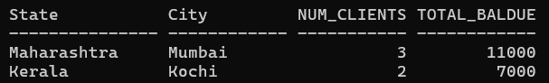
37. Display the product number, total quantity ordered, total quantity dispatched and percentage of undelivered quantity for products where total quantity ordered is greater than 5 and the undelivered quantity is greater than zero.
SELECT ProductNo, SUM(QtyOrdered) AS Total_Qty_Ordered, SUM(QtyDisp) AS Total_Qty_Disp,
ROUND((SUM(QtyOrdered)-SUM(QtyDisp))/SUM(QtyOrdered)*100, 2) AS Pct_Undelivered
FROM Order_Details
GROUP BY ProductNo
HAVING SUM(QtyOrdered) > 5 AND (SUM(QtyOrdered) - SUM(QtyDisp)) > 0;
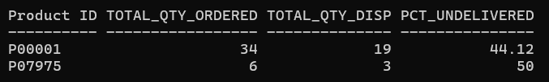
38. Display the order status, number of orders, minimum delivery duration and maximum delivery duration for each status, considering only statuses having at least two orders and maximum delivery duration greater than 20 days.
SELECT OrderStatus, COUNT(*) AS Num_Orders, MIN(DelyDate-OrderDate) AS Min_Dely_Duration, MAX(DelyDate-OrderDate) AS Max_Dely_Duration
FROM Sales_Order
GROUP BY OrderStatus
HAVING COUNT(*) >= 2 AND MAX(DelyDate-OrderDate) > 20;
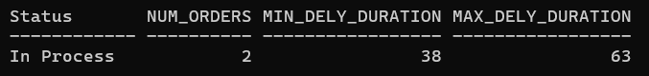
39. Display the city, number of clients, average balance due and maximum balance due for clients whose names have more than five characters, showing only cities with at least two such clients.
SELECT City, COUNT(*) AS Num_Clients, AVG(BalDue) AS Avg_BalDue, MAX(BalDue) AS Max_BalDue
FROM Cust_Master
WHERE LENGTH(Name) > 5
GROUP BY City
HAVING COUNT(*) >= 2;
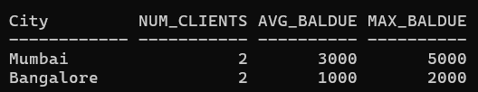
40. Display the product number, description, selling price and cost price for products whose description contains 'Jeans' or 'Tops', and display the selling price after applying a 10% discount.
SELECT ProductNo, Description, SellPrice, CostPrice, SellPrice*0.9 AS Discounted_Price
FROM Prod_Master
WHERE Description LIKE '%Jeans%' OR Description LIKE '%Tops%';
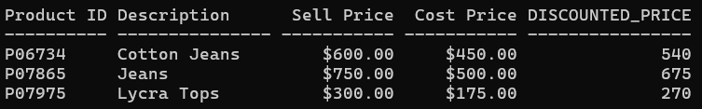
41. Display the year and month of order placement, number of orders and total quantity ordered for each year-month combination, showing only combinations having more than one order.
SELECT TO_CHAR(OrderDate,'YYYY-MON') AS Year_Month, COUNT(*) AS Num_Orders
FROM Sales_Order
GROUP BY TO_CHAR(OrderDate,'YYYY-MON')
HAVING COUNT(*) > 1;
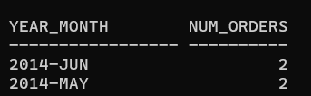
42. Display the order number, order date, delivery date and delivery duration for orders whose order date falls on a Monday or Friday and whose status is not 'Cancelled'.
SELECT OrderNo, OrderDate, DelyDate, (DelyDate - OrderDate) AS Dely_Duration
FROM Sales_Order
WHERE TO_CHAR(OrderDate,'DY') IN ('MON','FRI') AND OrderStatus <> 'Cancelled';
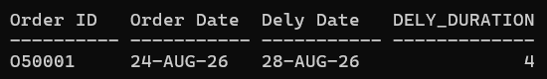
43. Display the unit measure, number of products, average selling price and average cost price for unit measures where the difference between average selling price and average cost price exceeds 150.
SELECT UnitMeasure, COUNT(*) AS Num_Products, AVG(SellPrice) AS Avg_SellPrice, AVG(CostPrice) AS Avg_CostPrice
FROM Prod_Master
GROUP BY UnitMeasure
HAVING AVG(SellPrice) - AVG(CostPrice) > 150;
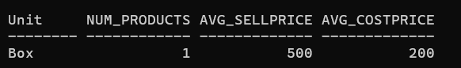
44. Display the state, number of clients, total balance due and average balance due for states having at least two clients, where the total balance due is greater than 5000 and the average balance due is greater than 1500.
SELECT State, COUNT(*) AS Num_Clients, SUM(BalDue) AS Total_BalDue, AVG(BalDue) AS Avg_BalDue
FROM Cust_Master
GROUP BY State
HAVING COUNT(*) >= 2 AND SUM(BalDue) > 5000 AND AVG(BalDue) > 1500;
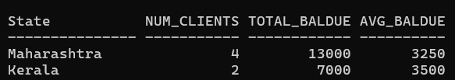
45. Display the product number, description, quantity on hand and stock status using a CASE expression to show 'REORDER' when quantity on hand is less than or equal to reorder level and 'SUFFICIENT' otherwise, for products whose description contains the letter 's'.
SELECT ProductNo, Description, QtyOnHand,
CASE WHEN QtyOnHand <= ReorderLvl THEN 'REORDER' ELSE 'SUFFICIENT' END AS Stock_Status
FROM Prod_Master
WHERE Description LIKE '%s%';
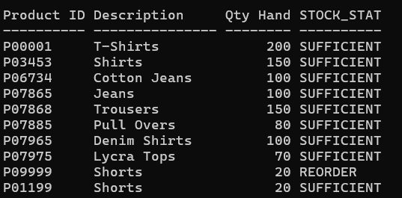
46. Display the month name, number of orders, total quantity ordered and average quantity ordered for each month, considering only orders placed between 01-FEB-2014 and 30-JUN-2014 and showing months having at least two orders.
SELECT TO_CHAR(OrderDate,'MON') AS Order_Month, COUNT(*) AS Num_Orders
FROM Sales_Order
WHERE OrderDate BETWEEN TO_DATE('01-FEB-2014','DD-MON-YYYY') AND TO_DATE('30-JUN-2014','DD-MON-YYYY')
GROUP BY TO_CHAR(OrderDate,'MON')
HAVING COUNT(*) >= 2;
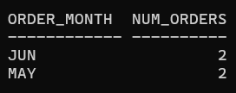
47. Display the payment mode, number of orders, average delivery duration and total delivery duration for payment modes having more than one order and total delivery duration exceeding 30 days.
SELECT Payment_Mode, COUNT(*) AS Num_Orders, AVG(DelyDate-OrderDate) AS Avg_Dely_Duration, SUM(DelyDate-OrderDate) AS Total_Dely_Duration
FROM Sales_Order
GROUP BY Payment_Mode
HAVING COUNT(*) > 1 AND SUM(DelyDate-OrderDate) > 30;
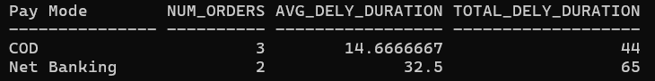
48. Display the product number, description, number of times the product appears in order details, total quantity ordered, total quantity dispatched and maximum quantity ordered, showing only products appearing at least twice and having total quantity ordered greater than 5.
SELECT ProductNo, COUNT(*) AS Num_Records, SUM(QtyOrdered) AS Total_Qty_Ordered, SUM(QtyDisp) AS Total_Qty_Disp, MAX(QtyOrdered) AS Max_Qty_Ordered
FROM Order_Details
GROUP BY ProductNo
HAVING COUNT(*) >= 2 AND SUM(QtyOrdered) > 5;
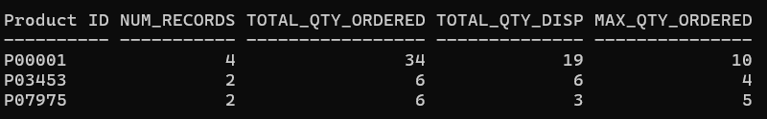
49. Display the client number, name, city and state for clients whose names begin with a consonant, whose balance due is greater than zero, and whose city contains the letter 'a', ordering the result by state and client name.
SELECT ClientNo, Name, City, State
FROM Cust_Master
WHERE Name NOT LIKE 'A%' AND Name NOT LIKE 'E%' AND Name NOT LIKE 'I%'
AND Name NOT LIKE 'O%' AND Name NOT LIKE 'U%'
AND BalDue > 0 AND City LIKE '%a%'
ORDER BY State, Name;
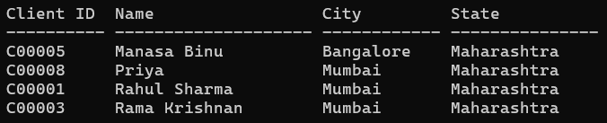
50. Display the product number, description, selling price, cost price and rounded difference between selling price and cost price for products whose selling price is greater than 500 or cost price is greater than 400, but whose profit percentage is less than 6%.
SELECT ProductNo, Description, SellPrice, CostPrice, ROUND(SellPrice - CostPrice, 2) AS Price_Diff
FROM Prod_Master
WHERE (SellPrice > 500 OR CostPrice > 400) AND ProfitPercent < 6;
